# Media Analysis - Is the Arab world ready for the uncertain age of AI-powered web tools_Updated 09 March 2023

## Short Summary

The passage discusses the rapid advancement of artificial intelligence AI , particularly in ChatGPT, which showcases its abilities in various tasks.

## Summary

ChatGPT, a large language model developed by OpenAI, has sparked conversation and controversy in various industries. While its ability to generate text based on patterns is impressive, there are concerns about the implications of such technology.  
  
One area where ChatGPT's potential impact is significant is education. As Ahmed Belhoul Al-Falasi, UAE minister of education, mentioned, AI can assist with content creation and learning materials, potentially streamlining educational processes.  
  
However, questions arise about the role of human teachers and the need for personalization in learning. Additionally, concerns exist regarding the accuracy of information generated by AI, which could have implications for students' knowledge and understanding.  
  
As AI continues to evolve and permeate various aspects of our lives, it is crucial that we approach its use with caution, consideration of ethical implications, and a recognition of the value and role that human intelligence and expertise bring.

## Question 1

To analyze how the media frames the public discussion about ChatGPT, I would follow these steps 1. Collect data Gather articles, editorials, and social media posts from a diverse range of media outlets. 2. Keyword analysis Identify key terms related to ChatGPT, such as AI , language model , creativity , ethics , and more. 3. Coding for metaphors Develop a coding system to identify and categorize metaphors used to discuss ChatGPT in the media. 4. Data visualization Create visualizations such as word clouds, network graphs, or heatmaps to display patterns in the use of metaphors across different media platforms. 5. Interpretation and conclusions Based on the analysis, draw conclusions about the dominant metaphors used by the media to frame the public conversation around ChatGPT.

## Question 2

The topic of artificial intelligence AI , particularly ChatGPT, is receiving widespread coverage from various perspectives and aspects 1. **Technical advancements** The impressive language generation abilities of ChatGPT are drawing attention. 2. **Impact on content creation** The potential for AI to augment or replace human writers in various industries. 3. **Ethical considerations** The discussion around bias, privacy concerns, and accountability in AI systems. 4. **Education and training** The implications for workforce skills and education as AI becomes more prevalent. 5. **Business opportunities** Forecasts valuing the AI market in trillions of dollars highlight the potential for economic growth. However, some aspects are being less covered or ignored 1. **Technical limitations** While impressive, there is a focus on the headline-grabbing features rather than discussing the underlying technical constraints. 2. **Short-term impact vs long-term implications** The immediate excitement around ChatGPT may overshadow discussions about how this technology will shape society and industries in the long run. 3. **Expert voices from academia and research institutions** While news outlets and industry experts are covering the topic, academic and research perspectives might be underrepresented. In conclusion, while various aspects of AI and ChatGPT are being widely covered, there is still room for a more balanced exploration of technical, ethical, educational, and long-term implications.

## Question 3

The Arabic World is mentioned in the context of the article discussing the global impact and adoption of AI, including potential applications and concerns. However, specific details about how the Arabic World leverages AI or any particular initiatives are not mentioned in this excerpt. Therefore, the answer is Not mentioned .

## Question 4

The final message of the article is that while AI holds promise and potential, it is unlikely to completely replace humans in the near future.

## Sentiment

The sentiment is 0.0

## Entities

UAE, Edge, National Strategy for Data, Jenna Burrell, Dan Milmo, Dubais Museum of the Future, the World Economic Forum, Sam Altman, GPT, Intelligence, Elon Musk, Bing, Googles, James Webb, Omar Sultan Al-Olama, Noaman Sayed, LEAP, Microsoft, Generative Pre-Trained Transformer, Google, Peter Thiel, AFP Founded, LinkedIn, Nowson, DeenSquare, AFP However, Minnesota University Law School, Data Society, Alex Hern, Alexa, ChatGPT, Scott Nowson, the Sciences Po school, YouTube, Bard, OpenAI, Reid Ho, AI, PwC Middle Easts, New York Citys, Arab News, Burrell, Guardian, Ahmed Belhoul Al-Falasi

## Highlights

#7cc867#fb5b89#c885da#f9cd59

## Wordcloud for #7cc867 Highlights

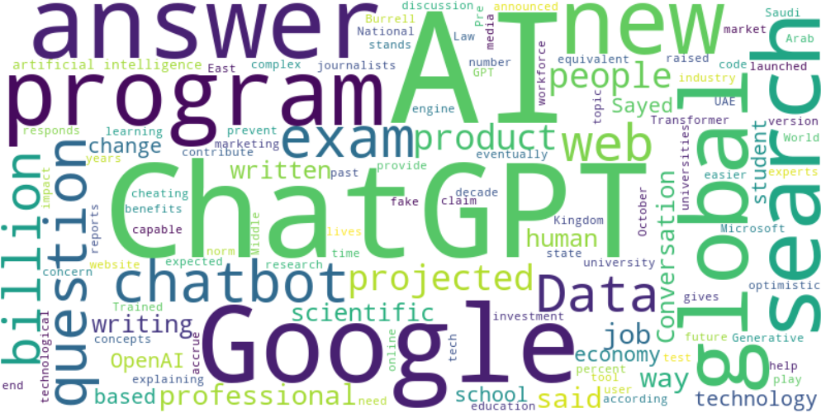

Top 10 words:

- AI: 16

- ChatGPT: 11

- Google: 7

- global: 5

- search: 5

- questions: 4

- web: 4

- billion: 4

- people: 4

- said: 4

## Wordcloud for #fb5b89 Highlights

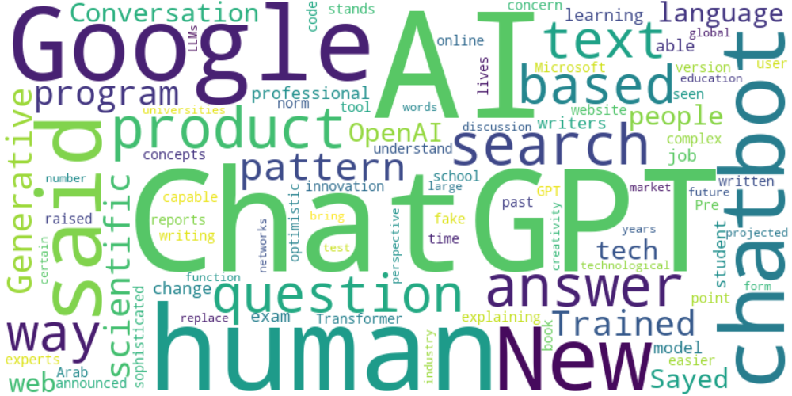

Top 10 words:

- AI: 12

- ChatGPT: 11

- Google: 7

- human: 5

- said: 5

- search: 4

- based: 4

- text: 4

- scientific: 3

- language: 3

## Wordcloud for #c885da Highlights

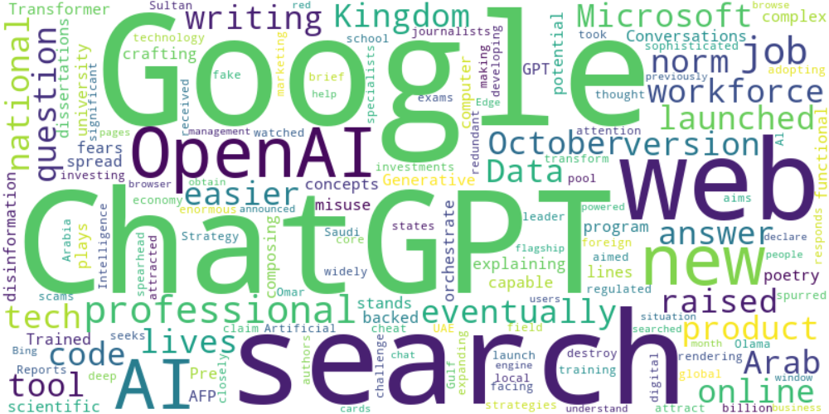

Top 10 words:

- Google: 6

- ChatGPT: 5

- search: 4

- web: 3

- OpenAI: 3

- AI: 3

- writing: 2

- code: 2

- Microsoft: 2

- raised: 2

## Wordcloud for #f9cd59 Highlights

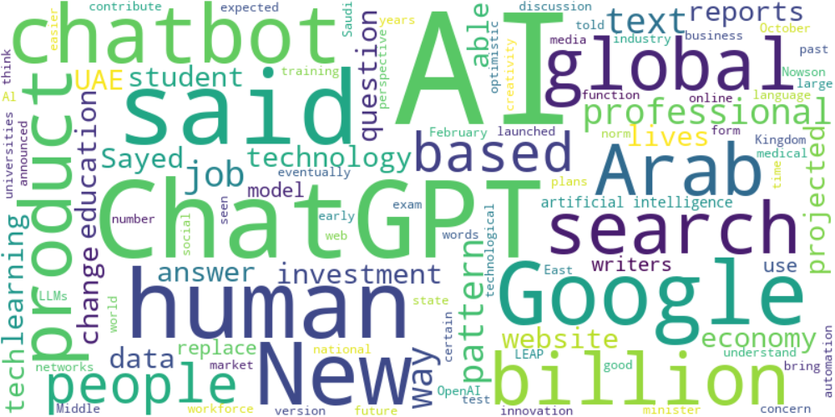

Top 10 words:

- AI: 24

- ChatGPT: 9

- said: 8

- Google: 6

- human: 5

- Arab: 4

- global: 4

- search: 4

- based: 4

- text: 4